A Signal Level Simulator for Multistatic and Netted Radar Systems

MARC BROOKER, Member, IEEE

MICHAEL INGGS, Member, IEEE

University of Cape Town

Efficient analysis of modern multistatic and netted radar systems requires a new generation of dedicated radar simulation software. Key requirements for such software are simulation accuracy and flexibility in choosing system parameters. In

this paper, algorithms for the simulation of raw radar return signals are presented based on interpolation and modification of the transmitted signal and modelling of the radar hardware and environment. This method supports simulation of pulsed and CW systems; monostatic, multistatic, and netted systems; phased-array radars; and most physically realizable radar system configurations.

Manuscript received February 15, 2008; revised November 30, 2008; released for publication August 1, 2009.

IEEE Log No. T-AES/47/1/940023.

Refereeing of this contribution was handled by Y. Abramovich.

This work was supported by the South African National Defence Force.

Authors’ address: Dept. of Electrical Engineering, University of Cape Town, Private Bag, Rondebosch, 7701, South Africa, E-mail: (marcbrooker@gmail.com).

0018-9251/11/$26.00 °c 2011 IEEE
I. INTRODUCTION

The ability to simulate the performance of a radar system early in the design life cycle is becoming increasingly important due to increases in system complexity and demand for radar systems that offer excellent performance at a low cost. Analysis of simple monostatic radar systems is well understood and can be performed without the assistance of specialised software [1]. In contrast, the analysis of complex radar systems is often intractable without the application of a dedicated radar simulation system.

Recent research into radar simulation has focused primarily on simulators for specific types of radar systems such as synthetic aperture radar (SAR) and moving target indication (MTI) systems. While special purpose simulators ([2] and [3], for example) are extremely useful in particular fields, the development of a general purpose simulator applicable to many types of radar systems (including future systems)

is interesting. Many past flexible simulators (such as [4]), while suited to the simulation of traditional radar applications, have severe limitations such

as the inability to simulate multistatic and CW radars.

This paper presents the design of general purpose software for the digital simulation of raw radar return signals based on the modelling of radar hardware and the environment and the modification of the transmitted signal using digital signal processing (DSP) techniques. The simulator has been designed for the accurate simulation of raw returns in complex, multistatic, and netted radars and is applicable to pulsed and continuous wave (CW) systems as well as both active and passive radar systems. In addition, active and passive electronically scanned array designs are supported. The algorithm is expected to be especially valuable for the simulation of emerging radar technologies, such as passive coherent location [5, 6] (PCL), netted radar [7, 8] and phased-array radar.

This paper describes the algorithms and models used for simulation, discusses their implementation, and compares simulation results with measured returns from the NetRad experimental netted radar system [7, 8], and theoretical predictions of MTI radar performance.

- RADAR SIMULATION MODEL

It is a convenient simplification to model the radar return signal as the sum of multiple independent target returns. In a simulated scene with T transmitters and S scatterers, the discrete-time return signal to the receiver r, y_{r}[ k] can be modelled as the sum of N responses (1) where N = T (S + 1). This simplification allows each scatterer to be considered independently,

178 IEEE TRANSACTIONS ON AEROSPACE AND ELECTRONIC SYSTEMS VOL. 47, NO. 1 JANUARY 2011

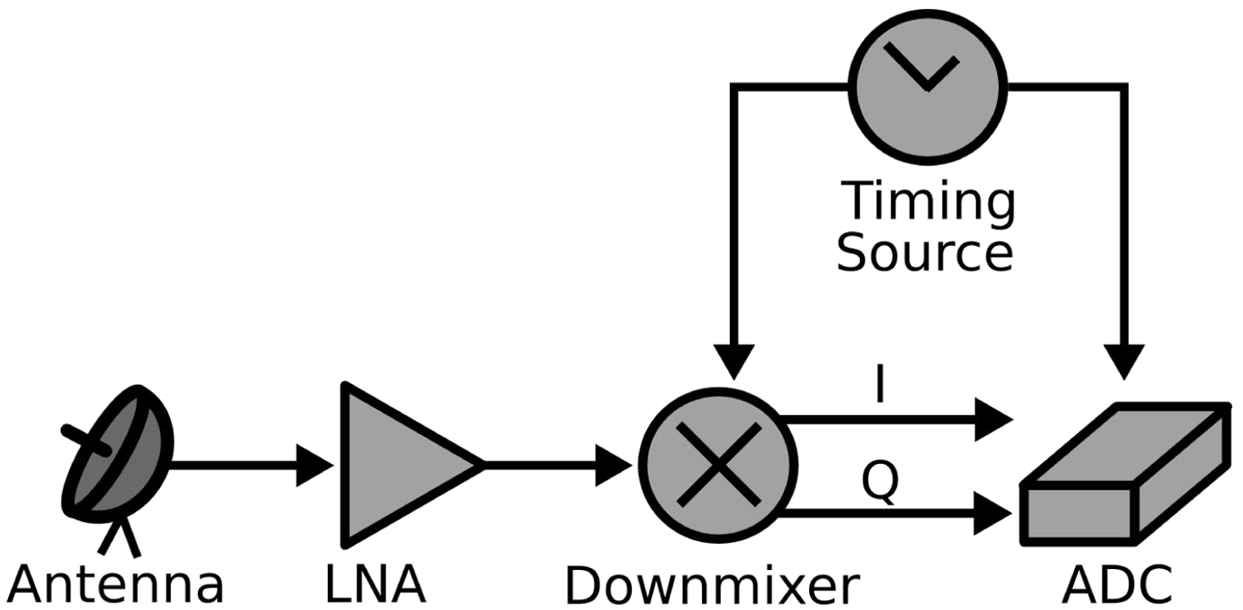

Fig. 1. Functional model of receiver hardware.

greatly reducing the complexity of the calculations required to simulate the return signal.

N
X_{i}
y_{r}[k] = s_{i}[k]: | (1)
=0

The scatterer returns s_{i}[k] are modelled as copies of the transmitted signal x[k] which have been modified by the effects of transmission, propagation, interaction with the scatterer, and reception. The signal s_{i}[k]

can therefore be expressed as the product of three processes which modify the transmitted signal x(n): transmission ( H_{t}(x)), environmental interaction (E(x)), and reception (H_{r}(x)).

 | N
y[k] = | ^{X}i
y[k] = | H_{r}(E(H_{t}(x[n]))): | (2)
 | =0

The radar simulation problem is equivalent to finding the functions H_{t}(x), E(x), and H_{r}(x), understanding how these functions affect the

transmitted signal, and applying these effects to copies of the transmitted signal. In the simulator described here, the hardware simulation functions H_{t}(x) and
H_{r}(x) are derived from a parametric hardware model, and the environment interaction function E(x) is derived from an environment model. The effects of these functions are applied to the transmitted function using DSP techniques.

A. Radar Hardware Models

The radar hardware model is based on two parametrized functional hardware models. The receiver model, as illustrated in Fig. 1, consists of a receive antenna, amplifier, quadrature downmixer, and signal capture hardware. The transmitter model is similar to the receiver model and consists of a signal source, quadrature upmixer, amplifier, and transmission antenna. Both models include a timing

source which provides time and frequency information to the other blocks, and both consider the effects of imperfections in the timing information received from this source.

The parameters of each functional block in the hardware model are changed to reflect the performance of the hardware of the system under simulation. Each functional block includes multiple tunable parameters, for example, gain, noise temperature, and bandwidth in the amplifier blocks
and the shape and amplitude of the phase noise curve for timing blocks. This functional model is sufficiently flexible to describe the performance of a large number of modern radar system designs.

B. Modelling the Effects of System Hardware

The effects of transmission (H_{t}(x)) and reception (H_{r}(x)) on the radar signal are calculated using the hardware model.

The intended effects of the transmission chain are to produce an analog signal, upmix it to the required transmission frequency, amplify it to the required transmission power, and transmit it using the required antenna gain pattern. The intended effects of transmission are therefore gain (from the amplifier and antenna) and the upmixing of the inphase and quadrature parts of the transmitted signal to a higher frequency. The unintended effects of transmission are linear effects (nonflat frequency response, etc.), nonlinear effects (amplifier distortion, digital-to-analog conversion (DAC) distortion, and timing source phase noise effects), and the addition of noncorrelated noise.

The intended effects of reception are to add gain to the signal (from the antenna and front-end amplifier), downmix the signal to IF or baseband, and possibly convert the signal into a stream of digital samples. Unintended effects of reception are similar to those of transmission, but also include the addition of distortion and quantization noise in the analog-to-digital converter (ADC). Where the radar hardware of interest performs more complex operations, such as beam forming and filtering, these operations can be included in the hardware modelling functions H_{t}(x) and H_{r}(x).

- Radar Environment Model

  - The Object Model: The environment model of the simulator recognises three kinds of objects: transmitters, receivers, and scatterers and accepts any number of each type of object in arbitrary geometric configurations. In addition, the model can include

a single surface which reflects radar energy for the simulation of specular multipath propagation. Each object in the environment is assigned a spatial position, path of motion through space, and rotation. Positions, velocities, and paths can be assigned exact values or statistical distributions of values.

Each transmitter in the model is independently assigned a waveform to transmit, an associated hardware model, and a transmission schedule. The transmission schedule models the pulse repetition frequency (PRF) of the transmitter. The transmitter object is intended to be used to model radar transmitters, the transmission part of monostatic radars, transmitters of opportunity (such as FM towers), noise sources, and active electronic warfare (EW) systems.

BROOKER & INGGS: A SIGNAL LEVEL SIMULATOR FOR MULTISTATIC AND NETTED RADAR SYSTEMS 179

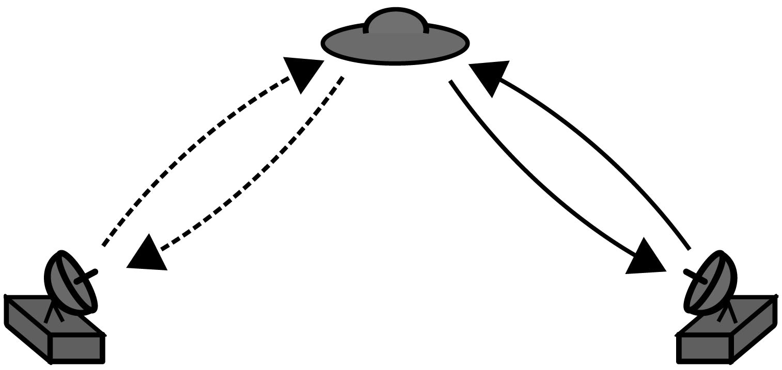

Fig. 2. Monostatic return paths in bistatic radar system.
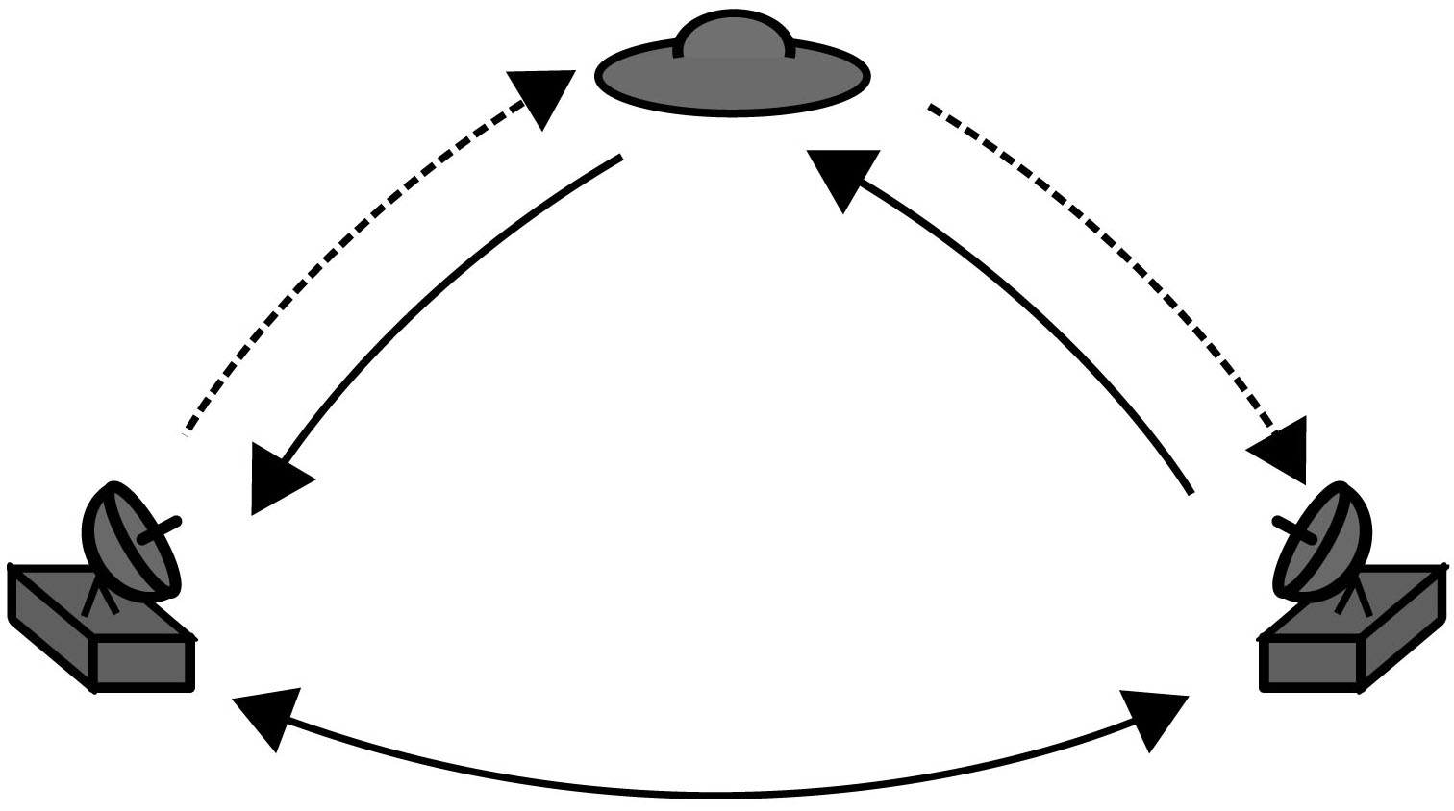

Fig. 3. Multistatic and direct return paths in bistatic radar system.

Receivers in the model are independently assigned a hardware model and receive schedule. The receive schedule is used to model range gating and can be slaved to the schedule of an associated transmitter. The receiver object models radar receivers and the reception part of monostatic radars.

Scatterers in the model are independently assigned monostatic or bistatic radar cross sections (RCS) and are used to model both intended targets, unintended targets (clutter) and mechanical jamming (chaff, etc.). Currently only point scatterers with arbitrary RCSs are supported. Note that this model does not make a distinction between intended targets and unintended targets (clutter)–the effects on the radar signal of both of these types of scatterers are the same.

2) Responses: Using the number of transmitters, receivers and targets in the environment, the model calculates the total number of responses for each transmitted pulse. In multistatic systems, monostatic (Fig. 2), multistatic (Fig. 3), and direct return paths are included in the total number of pulses. The presence of a multipath surface increases the number of responses as reflection paths are added to each bistatic pair.

In a multistatic radar system, the total number of returns per pulse seen by each receiver in a system with T transmitters, P targets, and S multipath simulation surfaces is RT( P + 1)(S + 1). Each of these returns can be considered independently and summed for each receiver, as in (1). This number is an upper bound on the number of responses–in some systems responses may be lost due to range gating, the effects of antenna gain patterns, and propagation effects.

Multiscatter (return paths which contain more than one scatterer) are not included in the calculation of N in Section II. Low-order mulitscatter paths
can be included directly in the calculation of (2) by extending E(x) to consider the effects of interaction with all targets on the path. The extension of (1) to a complete global illumination model (see [9], for example) would be required to consider higher order multiscatter paths, as direct calculation of these paths with (2) would not be computationally efficient.

D. Propagation Effects

Propagation through the atmosphere has two major effects on signals transmitted at common radar frequencies: delay and attenuation.

The effects on the received radar signal due to the delay caused by propagation can be decomposed into two effects: a phase shift on the carrier (phase delay) and a time shift of the envelope of the transmitted signal (group delay), assuming that the transmitted signal consists of a complex bandlimited signal that is mixed with a carrier at a constant frequency. Considering these two effects separately simplifies the computational task of signal processing as the computationally complex group delay simulation only needs to be applied to the baseband signal.

Most simulators described in the literature assume that the phase and group delay are constant throughout each pulse ([4], for example) and that motion occurs during the inter-pulse interval. This stop- go assumption is only valid for radar systems with short pulses and those where the target range is changing slowly. The maximum allowable simulation error depends on the type of processing used on simulation results. Doppler velocitometry techniques, for example, do not consider the change of phase and group delay over the pulse interval, making the errors introduced by assuming stop-go behaviour irrelevant.

The second major effect of signal propagation through the atmosphere is attenuation. The power of the return signal, for the case where the signal

bandwidth is much less than the carrier frequency, can be computed using the radar (3) for target reflections and (4) for direct return paths [1].
P | = |  | PG G ½ ¸² |  |  | (3)
P |  |  |  | t t r b |  | (3)
r |  |  |  | (4¼)³R²R²
 |  |  |  | t | r
and |  |  |  | PG G ¸²
P |  | = |  |  |  | (4)
 |  |  |  | t t r |  | (4)
 | r |  |  | (4¼)³R²
where P_{t} is the transmitted power, G_{t} and G_{r} are the gain of the transmit and receive antennas in the direction of the target, ¸ is the carrier wavelength, and R, R_{t}, and R_{r} are the lengths of the direct path, transmitter-target path, and target-receiver path, respectively. ½_{b} is the bistatic RCS of the target corresponding to the arrival and departure angles. For monostatic paths, (3) is used, with R_{t} = R_{r} and ½_{b} equal to the monostatic RCS.

180 IEEE TRANSACTIONS ON AEROSPACE AND ELECTRONIC SYSTEMS VOL. 47, NO. 1 JANUARY 2011

For wideband signals, the return strength is frequency dependent. In this case, a linear phase digital filter matching P_{r} / ¸² is designed using the fast Fourier transform (FFT) and applied to the signal.

The radar equation provides a simple calculation for the power of the return signal, but does not include attenuation due to atmospheric factors. Attenuation due to propagation through the atmosphere is frequency dependent and varies widely across commonly used radar bands. The attenuation coefficient can be found in many standard references (such as [1]) and multiplied by the propagation distance (R or R_{t} + R_{r}) to find the attenuation due to atmospheric propagation.

This model is not limited to the linear phenomena of attenuation and delay. In order for the calculation in (2) to be valid, the propagation medium must be linear. It is not assumed, however, that the permittivity (²) and permeability (¹) of the medium are constant and scalar. The environment model can include effects such as dispersion (where ² and ¹ are functions

of frequency) and anisotropy (where ² and ¹ are second-rank tensors).

III. SIGNAL PROCESSING

Following the identification of the simulation transfer functions H_{t}, H_{r}, and E , DSP approaches are used to modify the transmitted signal to match the expected parameters of the received signal.

A. Phase Delay and Doppler Shift

The phase of the carrier at the receiver is determined by the signal propagation time. Where this time is not constant, the changing phase shift is seen as a frequency or Doppler shift on the received signal. In this simulation, the per-sample phase shift '(t)

is calculated from the carrier frequency and bistatic range of the transmitter, target, and receiver using standard relativistic Doppler calculations. Considering the phase effects of propagation as a per-sample phase shift '(t) rather than a fixed frequency shift, allows the model to offer per-sample Doppler accuracy without making assumptions about the speed of target movement or the length of pulses.

Using a relativistic model to consider the phase shift introduces further accuracy by relaxing the assumption that targets are moving at a small fraction of the speed of propagation.

The inphase I and quadrature Q parts of the downmixed return pulse are calculated from '(t) and the real and complex parts of the transmitted pulse.

I[k] = ₂¹ R(y[k]) cos(Á) ¡ ₂¹ I(y[k]) sin(Á) | (5)
Q[k] = ₂¹ R(y[k]) sin(Á) + ₂¹ I(y[k]) cos(Á) | (6)

where R(x) and I (x) are the real and imaginary part of x, respectively, and Á = '(k=f₀).
B. Group Delay

The application of time-dependent group delay to a digital signal requires a tradeoff to be made between computational speed and accuracy. For constant group delay of an integer number of samples, the sample stream can simply be shifted. For noninteger delays, simulation of group delay requires interpolation of the samples.

Finite impulse response (FIR) fractional delay filters, based on windowed truncation of the ideal bandlimited interpolation [10] filter, are used to apply time-dependent group delay to discrete-time signals. The exact values of the samples of the delayed signal d_{i}[k ] (properly sampled at f₀ Hz) can be calculated from the transmitted signal x[n] and the time-dependent delay function T_{d}(t) using the summation in (7) [11]
^{d}i^{[k] =} _{n=} |  | x[n]h_{s} ^{μ}k ¡ T_{d} | ^{μ}f₀ |  | ¶¡ _{n}¶ | (7)
 | 1 |  |  | n
 | X
 | ¡1
h | _{(t) =} sin(¼t) : |  |  |  |  | (8)
s | ¼t

If the delay function is not constant, the delayed signal d_{i} [k] undergoes an apparent shift in frequency. In cases where the frequency shift causes a net increase in frequency, it is critical that the sample rate f₀ is sufficiently high that the delayed signal d_{i}[k] is properly sampled, or distortion will occur due to aliasing.

The process described in (7) can be understood as convolution of the transmitted signal with a digital filter with the required group delay. The filter function h_{s}(t) cannot be precomputed as the group delay is time varying.

1) Implementation of Group Delay Algorithm: A direct implementation of the summation (7) is impractical as it requires O(N² ) operations for x[n] with length N. Evaluating (7) using a FIR approximation of the ideal interpolation filter (8) reduces the runtime to O(N) at the cost of numerical accuracy.

Simple truncation of the filter function h_{s}( t) will severely reduce the stopband attenuation of the interpolation function, increasing distortion and aliasing. This effect can be effectively reduced by the application of a suitable window function to h_{s}(t) prior to truncation. The Kaiser window [12, 13] is ideal for this application [14], as the compromise runtime, flatness of the passband, and bandwidth can be adjusted with the window parameters ¯ and N without changing the algorithm implementation. The desired value of ¯ and window width M

can be calculated using the method described by Kaiser [12].

Application of the Kaiser window function to truncate h_{s}(t) to M samples produces (9) to

BROOKER & INGGS: A SIGNAL LEVEL SIMULATOR FOR MULTISTATIC AND NETTED RADAR SYSTEMS 181

replace (8) |  | 8 | j j | ¼t |  | , | jtj · M, | (9) | SQNR can be expressed as |  |  |  |  |  | ₂ ^{+ 10 log}10 |  |  |  |  |  |  | 2B
h_{s}(t) = |  | 8 | j j | ¼t |  | , | jtj · M, | (9) | SQNR = 20 log₁₀ 2 |  |  |  | + 20log₁₀ ^{r}
 |  |  | w( t ) sin(¼t)
 |  | < |  |  |  |  |  |  |  |  |  | N |  |  |  | 3 |  |  |  |  |  | f_{s}
 |  | < | 0, |  |  |  | otherwise |  |  |  |  |  |  |  |  |  |  |  |  |  | (10)
where w(t) is | the zero-centered Kaiser window |  |  |  |  |  |  |  | for an N-bit ADC with sampling rate f_{s} |  |  |  |  |  |  |  |  | [17].
where w(t) is |  | :
function with length M and shape ¯. |  |  |  |  |  |  |  |  | The simulator directly simulates A/D quantisation
The Kaiser window function is computationally |  |  |  |  |  |  |  |  | effects by truncating simulation results to the
expensive–evaluating it requires two calculations of |  |  |  |  |  |  |  |  | required number of bits. This approach, while more
the value of the zeroth- order modified Bessel function |  |  |  |  |  |  |  |  | computationally expensive than the addition of
and one square root. In simulations of long periods or |  |  |  |  |  |  |  |  | pseudonoise, offers a more accurate simulation of A/D
high bandwidths, an optimisation of this calculation |  |  |  |  |  |  |  |  | effects, including the nonlinear effects of quantisation
could be desirable. |  |  |  |  |  |  |  |  | to a small number of bits.
The simulated described in this paper uses a
twelfth- order polynomial approximation of I₀ |  |  |  |  |  |  |  | (x) (from | D. Phase Noise and Jitter Effects
[15]) as the base of an approximation to the true |  |  |  |  |  |  |  |  | Errors in the time and frequency sources in the
Kaiser window function. The maximum error of this
 |  |  |  |  |  |  |  |  | radar system have several effects on the received
approximation is less than 1:2 £ 10¡⁸. The simulator
 |  |  |  |  |  |  |  |  | signal.
uses this function to populate a variable sized table of |  |  |  |  |  |  |  |  | The most obvious effect is the gross errors due to
subsample delay filters. The loss in accuracy due to
 |  |  |  |  |  |  |  |  | timing inaccuracy which cause incorrect referencing
this approach depends on the table size: for a table of
 |  |  |  |  |  |  |  |  | of the time of the received signal compared with the
10⁵ filters of length 32, the maximum interpolation
 |  |  |  |  |  |  |  |  | transmission time. The simulator handles these errors
delay is ¡83 dB. In cases where this accuracy would
 |  |  |  |  |  |  |  |  | by adding random perturbations to the timestamps
limit the dynamic range of the simulation (that is, |  |  |  |  |  |  |  |  | recorded for received data, corresponding to the jitter
systems with over 13 bits of dynamic range), the table
 |  |  |  |  |  |  |  |  | on the timing source in the receiver hardware model.
size can be increased.
 |  |  |  |  |  |  |  |  | Phase noise on the timing source has an effect on
C. Addition of Noise and Distortion |  |  |  |  |  |  |  |  | the upmixing and downmixing steps of the hardware
 |  |  |  |  |  |  |  |  | model. To simulate these effects, the instantaneous
The key limiting factor on the performance of |  |  |  |  |  |  |  |  | phase deviations in the transmitter ('_{t}) and receiver
radar systems is the signal-to-noise ratio (SNR) of |  |  |  |  |  |  |  |  | ('_{r}) timing sources are added to the phase shift
the return signal. It is therefore important to correctly |  |  |  |  |  |  |  |  | factor ' in (5) and (6). The instantaneous phase
 |  |  |  |  |  |  |  |  | deviations '_{r} and '_{t} are generated from a statistical
model the noise received along with the return pulse.
1) Additive Noise: |  |  |  | For narrowband radar systems |  |  |  |  | model of the phase noise present on the timing
 |  |  |  |  |  |  |  |  | source. The simulator uses a novel multirate filter
(where the bandwidth is much smaller than the carrier
 |  |  |  |  |  |  |  |  | structure (described in [18]) to accurately generate
frequency), the additive noise can be considered
 |  |  |  |  |  |  |  |  | samples of phase noise matching the characteristics
Gaussian noise with a constant spectral density.
 |  |  |  |  |  |  |  |  | of the oscillator technology used in the system under
The total system noise consists of the sum of the
 |  |  |  |  |  |  |  |  | simulation.
noise picked up from the environment and the noise |  |  |  |  |  |  |  |  | simulation.
 |  |  |  |  |  |  |  |  | A third effect of phase noise on the timing sources
created by the transmission and reception systems.
 |  |  |  |  |  |  |  |  | is a degradation of the performance of the A/D
For simulation of most practical radar systems, it
 |  |  |  |  |  |  |  |  | and D/A converters in the receiver and transmitter.
is sufficient to specify the equivalent system noise
 |  |  |  |  |  |  |  |  | Presence of jitter on the data conversion of the clock
temperature, generate bandlimited white Gaussian
 |  |  |  |  |  |  |  |  | reduces the SNR of the data converters. An error term
pseudonoise, and sum it with the return signal.
 |  |  |  |  |  |  |  |  | is added to the group delay simulation (7) to simulate
The system noise temperature depends on the
 |  |  |  |  |  |  |  |  | the effects of jitter on data conversion [19]. Jitter
environment, the elevation and gain pattern of
 |  |  |  |  |  |  |  |  | samples are computed from numerical integration of
antennas, and the noise figure of the amplifiers used
 |  |  |  |  |  |  |  |  | the phase noise model of the timing source [18].
in the transmitter and receiver.
2) Quantisation Effects: |  |  |  |  | Additional noise and |  |  |  | IV. CALCULATING THE RAW RETURN SIGNAL
distortion is added by the D/A converter in the
 |  |  |  |  |  |  |  |  | Using the equations developed above, a complete
transmitter and the A/D converter in the receiver. In
practical cases, the effects of A/D conversion can be |  |  |  |  |  |  |  |  | equation (11) for the samples of the raw radar signal
assumed to be purely additive and the additive noise |  |  |  |  |  |  |  |  | as received by receiver r can be obtained. |  |  |  |  |  |  |  |  |  |  |  | [k]¹:
signal e[ n] assumed to be stationary and uncorrelated |  |  |  |  |  |  |  |  | T |  |  |  | P
with the signal being quantised [13, 16]. The |  |  |  |  |  |  |  |  | T | k |  |  |  |  |  |  |  |  | k
 |  |  |  |  |  |  |  |  | y_{r}[k] = _{t=0} ⁰A_{tr} ^{μ}
signal- to-quantisation noise ratio (SQNR) depends |  |  |  |  |  |  |  |  | y_{r}[k] = _{t=0} ⁰A_{tr} ^{μ} |  | ¶ |  | ^{d}tr^{[k] +} _{p=0} ^{A}tpr ^{μ} |  |  |  |  |  |  | ¶d_{tpr}
 |  |  |  |  |  |  |  |  | y_{r}[k] = _{t=0} ⁰A_{tr} ^{μ} | f₀ |  |  |  |  |  |  |  |  | f₀ | ¶d_{tpr}
on the properties of the return signal and the sampling |  |  |  |  |  |  |  |  | X@ |  |  |  | X |  |  |  |  |  |  |  |  | A
rate. For a typical radar signal with bandwidth B, the |  |  |  |  |  |  |  |  |  |  |  |  |  |  |  |  |  |  |  |  | (11)

182 IEEE TRANSACTIONS ON AEROSPACE AND ELECTRONIC SYSTEMS VOL. 47, NO. 1 JANUARY 2011

